### 

# University of Toronto Students: Academic vs Social Life

Unique Corns

CSC318H1

Fanny Chevalier and Khai Truong

### 

Parth Champaneri, Allen Hsiao, Clare Kim, Jenny Kondrashikhin, Pascal Queeney, Patrick Tan

Monday, October 22 2018

**Table of Contents**

**University of Toronto Students: Academic vs Social Life**

Introduction 2

Summary 3

General Problem 4

Field Studies 6

Formative Study # 1: Questionnaire 6

Protocol 6

Summary of Results 7

Formative Study # 2: Interview 9

Protocol 9

Summary of Results 10

Experience Map 12

Job Stories 13

Design Requirements 14

Appendices 16

Group Management 17

### 

### Introduction

The project we are working on is based on CHI - 2019 theme of weaving the threads, which is the connection of strength and friendship. The challenge for this year is

*“to consider how technology can enhance how people weave together within communities and wider society as a whole.”.*

We will look into different technologies, and their applications that will help build a closer community. In this paper; you will see the initial problem(s) we developed, in-depth formative studies, a journey map of the user, job stories and a potential solution to the problem.

### 

### 

### Summary

Throughout the research study, we conducted two formative studies consisting of a questionnaire and interview. These were based off a research problem on connecting the students at UofT closer together by bridging the gap between academic and social lives. Through the results of our formative studies, we understood that we particularly wanted to focus on helping UofT students connect both academic and community events to help strengthen the social lives between students. From these results, we created both a journey map and job stories resembling common challenges different users may encounter whilst “finding an event”. After brainstorming different challenges, we generated different design requirements that will help create an efficient yet compatible solution for the student body of University of Toronto.

### General Problem

For our project we decided to focus on bridging the gap between the academic and social life of a student. Many students find it hard to balance both lifestyles, and we want to weave a tighter community within the student body. We are looking to make connections among university students, specifically for students that put a priority on academics but are open to social events. We aim to make school events, social events, and university clubs more findable & accessible for students undergoing stress, anxiety, or busy schedules. Ultimately we want to make the university life more enjoyable by promoting and increasing access to resources. To give students the choice to become more engaged with their peers despite having a busy schedule, workload, or little motivation to connect with others.

Whilst developing the problem statement, we looked into problems we faced within our group and did brief research on current problems that are found within different student bodies. Particularly within our group, we found that finding groups with similar interests is the hardest challenge. Upon research, we looked at current implementations like Facebook events, Eventbrite, Foursquare, and Meetup. Solutions like these work to an extent but in some cases like Facebook events, they show multiple events in the area, and it can be overwhelming to find new events and organisations that fall within the interests of the user. The problem with this is finding niche hobbies. Users generally have to join different clubs and look to see if they are hosting any events. With applications like Foursquare and Meetup, it is frustrating to find similar interest groups . There is no advanced filtering, and a lot of events are hosted by companies promoting different campaigns. But specifically in these solutions, we were not able to find many events in UofT. It was assumed there was not enough exposure and activity in the campus. Thus, in this study, we decided to particularly look at University of Toronto students. Since we know UofT has a large diversity of students, we are looking to understand what is needed to strengthen the student body’s relationship within the university. Our main target is students busy with school, but our stakeholders consists of the general student body because we want to develop a solution that can connect students of various backgrounds. Within the student body, we will encounter various students each with their own unique problems. For instance, there are students who value school work over social events, students who are at school particularly for sports, and students for whom social events are an important complement to their studies. First year students and upper year students also differ in their motivation to socialize. First year students are encouraged by frosh events to meet new people and build a new circle from scratch, but large lecture classes can also be intimidating. Upper year students have smaller sized classes and tutorials, however many have already established their own social circle. Ultimately there are many different types of students from exchange to international, from undergraduate to graduate, that all have different motivations to get involved within the social community of the school, and we want to find a way to bring it all together.

Although this research particularly focuses on the University of Toronto, the research can be implemented for any University or College. Helping bridge the gaps between different social & academic lifestyles across a variety of campuses.

### 

### 

### **Field Studies**

#### **Formative Study # 1: Questionnaire**

##### **Protocol**

We created a questionnaire using Google Forms, and distributed the survey on social media, link sharing, and Email. We chose this media due to the ease of sharing the survey as well as collecting the data digitally, however we understand that there may be bias in our convenience sampling, since we only limit ourselves to people who uses social media and email.

A draft of the survey was first shared amongst the group members, and piloted. Through the pilot, we added more specific demographic questions, added more options to some of the multiple choice answers, and created more open ended long answer questions. One main thing we fixed was the organization of the questionnaire. At first the questions were all over the place, but after piloting the questionnaire, we realized that it was difficult to follow the questions, and therefore divided the questionnaire into distinct categories spread over several pages, and added a progress bar.

The five main categories in the final questionnaire consists of demographics, social media use, social events, clubs and organization, and follow up. Each section consists of simple multiple choice questions leading to short and long answer questions. We let all our participants know that the survey is used for a research study, and the collected data will remain anonymous. The questionnaire was shared and closed within a week, with a total of 24 participants.

We chose to do a questionnaire as our first formative study because it is the fastest way to obtain general information about a big population. The questionnaire can be quickly distributed, and the responses can be quickly gathered. Our stakeholder is the student population, which is quite large, therefore using a questionnaire can allow us to cover more ground, and identify a shared problem among the student population.

##### **Summary of Results**

A note, after collecting all responses from the participants, we noticed majority of our participants are upper year students. Thus we taken into consideration the biased answers, as their experience at University of Toronto will be different to first year and international/exchange students.

In the questionnaire we found a common trend between the participants which is the balance of social life and academic life. This trend was anticipated because we understand that university students are known to live a busy lifestyle. From this, we ideally knew what we wanted to learn in our next formative study (Interview) and looked to find a deeper reasoning on what in particular is the root cause of difficulty balancing both social and academic life.

Another pattern we noticed upon our analyses is many of our respondents were commuters to UofT. This was also assumed prior to our research because it is known for all three campuses to be a commuter school. But what is particularly interesting with this feedback is seeing how involved the commuters are with social and or academic events at school. To further understand how active these students were, we looked into what events are the respondents interested in. Many of these students were looking for study groups, similar hobbies, and socials (parties, program events, networkings). Understanding that most of the respondents were commuters looking for activities on campus, we were able to narrow our focus to creating a solution that can implement a resource that will allow students connect with others in similar programs, courses and interests.

Lastly, an important analysis point is that majority of the students found current resources do not provide a sufficient way to discover and locate different events across campus. As stated previously, most events are hosted through different clubs and organizations of the school and these are not necessarily widely promoted throughout the university. In this case, understanding this particular response made us think that the current implementations are not the most efficient way of getting news or events across. We can further develop this by following this question up in the interview study because then we can find what is specifically hard in finding certain events within the campus.

This questionnaire helped us understand the different pain points that students currently face at the university. Letting us now know what areas to focus on in the interviews and help map out a potential design solution in connecting the students at UofT closer together.

#### 

#### **Formative Study # 2: Interview**

##### **Protocol**

Students who answered “yes” for a follow up interview were contacted by email or social media and scheduled approximately 30 minutes of their time for an interview. The interview is semi-structured, there is a script prepared with questions to be asked, but some questions were omitted, or added depending on what was relevant for the particular interviewee. Study rooms were used to conduct the interview. Interviewees were asked if they can be recorded on a voice recorder, and told that they are free to not answer any questions or leave if they feel uncomfortable. We explained the overall premise of the study to the participants, and explained that we are looking to understand student engagement, and particularly how students find events, and get involved within the school.

The interview script consists of three main parts: ‘warm-up’, ‘the balance between social and academic life’, and ‘finding and engaging in social events’. The script was created by collectively deciding on the important questions that we wanted to ask. Questions that are too specific, and possibly leading were eliminated, and then we finalized a general script using the remaining questions. Depending on the interviewer the order of the questions may vary depending where the direction of the interview went. Right before we started interviewing, we organized the questions based on the specificity and difficulties, leaving more open-ended, and harder questions near the end of the interview.

The interview was chosen as our second formative study because we wanted to identify and hear the voices of students on what they feel in particular was lacking for student engagement. From the questionnaire we learned the problem of school can overshadow the importance of socializing and being involved. An interview is a good way to hone in on that specific aspect of the problem, and find out whether that problem truly exists. Interviews can also give us insight on the particular feelings from students, and specific problems and associated coping strategies that each individual develops.

##### **Summary of Results**

From the interview we found several major points of interests. First, during the questions about school and social life, students who were interviewed all mentioned that school life was more important to them than social life. However they also mentioned that social life is still a crucial part of student life, for reasons such as helping relieve stress. School schedule was identified as one of the major problems in terms of balancing academic and social life. This problem is the main reason for most interviewees to not be as active within the social community as they would like.

Another major finding and common trend is the use of friends as well as social media as the main resources for finding events. Friends are especially important, as for many interviewees they feel that friends are an important factor required for them to want to participate in certain events. Friends also have shared interests, and can reduce the anxiety of going to social events alone.

One major conflict that connects the both friends and school schedules is that often people have different schedules than their friends. One interviewee mentioned that it would be ideal if everyone had the same, or more similar, schedule for midterms and assignments.

Some common coping strategies that were identified for conflict of schedules is preplanning and knowing the dates of the events far in advance. Having a better resource for students to time manage and having more accessibility to the times when events are held seem to be important factors for students who are trying to balance school and social life. Another coping strategy for students is to have friends to go with, or simply recommend events. Friends have been repeatedly mentioned and seem to be the most reliable and trusted source for students. Therefore another important point to consider is that knowing what events friends are participating in can be helpful in getting more people to become more involved in social events.

### 

### 

### Experience Map

### **Job Stories**

Below, are different job stories that are created based on the participant interviews to help identify different challenges they are facing.

1. When I have a busy schedule and school work, I want to look for social events that fit into my schedule, so I can still have a balance between social life and academic life.
2. When I cannot find social events that fit my interests, I want to look on social media to see what events my friends are interested in, so I know what events are available and which friends I can go to the events with.
3. When I have anxiety attending social events by myself, I want to know which friends are attending certain events to ask friends to attend events with me, so I can have someone to go to the events with.
4. When I know I have assignments and midterms coming up, I want to know what events are available far in advance and finish my work early, so I do not have to stress when I attend the social event.
5. When I am looking to make friends at school and join more social events, I want to look into becoming a member of a student club the I am interested in, so I can follow up on the events hosted by that club and meet people that have the same interest as me.

### **Design Requirements**

1. The design must incorporate social media, either being a feature on social media as an extension, or allows users to connect to their social media. Social media is an important resource currently for students to connect to social events. Following up the formative studies we need to research on current solutions that are available for students to find events and engage with others (Facebook Events, MeetUp), and find out what it is that is lacking in those solutions.
2. There must be a feature on the solution that can allow users to connect with friends and look at what events their friends are planning to participate in. Friends are an important factor for students, and encourages more student involvement as we found out from our formative study. Therefore the design must be able to allow users to view what their friends are participating in, and make it easily accessible.
3. The solution design should focus on the problem we set up specifically, and should not be too general. This means that the solution should tailor toward social engagement and social events for students, and should not try to solve any other problems or have additional features. Additional features that do not focus on social events might make the solution too complicated and too hard to use. Facebook is a good example of an application that has a lot of different features. We should not aim to solve too broad of a problem, especially with our time constraint as well. This also mean that the design of the solution should be easy to use, with a simple interface.
4. The audience for the design is tailored for students, therefore the design should focus on being for students, but also be able to accommodate for different types of students. The design of the product should be accessible to every single student, which means that it should be inexpensive, and available at least U of T wide. There should not be any problems or issues with any students being able to use the product, and ideally every single student would be using the product. The solution should also be designed for convenience, since our target audience and main problem statement deals with busy university students, the solution should be easily accessible, without much hassle, or unnecessary setup.
5. The design of the product should protect the user’s privacy and information. Although we want to develop something that will get student to be more engaged, we do not want to design something that will jeopardize and leak personal or private information about the user. The solution should aim to protect the user’s private information, while still allow users to connect with their friends and see what their friends are doing around the campus.

### 

### 

### **Appendices**

Please refer to the extra documents at the bottom of this PDF file;

* Research Protocol
* Consent Form
* Questionnaire Questions
* Interview Questions

### 

### 

### **Group Management**

|  |  |  |  |
| --- | --- | --- | --- |
| **Member** | **Task** | **Description** | **Time** |
| Parth | Introduction,  General Problem | Introduce the CHI 2019 project, and help revise the research problem for the study | 2 Hours |
| Allen | Formative Study #2, Experience Map | Explain results of formative study #2, and create experience map based off the data | 3 Hours |
| Clare | Job Stories | From formative study #2 and experience map, create detailed job stories of user challenges | 2 Hours |
| Jenny | Design Requirements,  Analyze Data | Analyze, graph, and transcribe formative study data. Create a detailed list design requirements for the solution | 2 Hours |
| Pascal | Design Requirements,  Analyze Data | Analyze, graph, and transcribe formative study data. Create a detailed list design requirements for the solution | 2 Hours |
| Patrick | General Problem, Formative Study #1 | Introduce the problem we decided to conduct our research on, explain current implementations and results of formative study #1 | 3 Hours |
| Everyone | Revisions | Regularly check work, in regard to grammar, punctuation, and sentence repetition | Frequently |

**Consent Form: Questionnaire and Interview of ‘Students: Academic vs Social Life’**

I hereby consent to participate in a research study conducted by ____________________ for an assignment in University of Toronto Computer Science 318, Design of Interactive Computational Media.

I agree to participate in this study, the purpose of which is to understand how students engage themselves in academic studies and attending social events.

I understand that: The procedures to be used are that I will be answering a series of questions regarding my student life at U of T. The questions consists of multiple choice, short answer, and long answer questions. I will answer them to the best of my abilities. All questions and answers will be recorded by the investigators.

I will receive no compensation for my participation.

I am free to withdraw before or any time during the study without the need to give any explanation.

All materials and results will be kept confidential, and, in particular, that my name and any identifying or identified information will not be associated with the data.

PARTICIPANT

Name (please print)

Signature

Date

INVESTIGATOR(s)

Name Signature

**Research Protocol**

1. Project Title: Questionnaire and Interview of ‘Students: Academic vs Social Life’

2. Investigators: Parth Champaneri, Allen Hsiao, Clare Kim, Jenny Kondrashikhin, Pascal Queeney, Patrick Tan.

3. Purpose: The purpose of our research is to understand how students look to find opportunities for social engagement, how student balance their academic life and social life, and the general use of social media among students to help us derive requirements for the design of novel interactive computational media that are intended to be useful to university students that are too busy to engage within the social community. A brief description of our design problem is: We aim to help student balance their academic and social life by connecting students through accessibility to resources for student engagement thereby strengthening the bond within faculties and student communities.

4. Process to be followed: We will brief the participants about the purpose of the study, explain the consent form to them, and ensure that they sign the consent form. We will then engage the participants in a public questionnaire, and have a second study based on a semi-structured interview. We will also, with their permission, make observations as follows: record the audio in the second formative study of interviews.

5. Participant selection: Participants will be chosen from the University of Toronto student body. They will be identified via their current student status (part-time or full-time) and selected according to their agreement to participant. In general, they will be characterized as full time or part time students, from age 18 to 29.

6. Relationships: Our relationship to the participants may be described as follows: fellow students within University of Toronto.

7. Risk and benefit: There will be minimal risk to the participants, for example that they feel that they have wasted their time. The only benefit will be to contribute to the education of the investigators. Participants are free to withdraw before or at any time during the study without the need to give any explanation.

8. Consent details: We will brief the participants about the purpose of the study, and explain the attached consent form to them, and ensure that they consent to participate and sign the consent form.

9. Compensation: Participants will receive no compensation.

10. Information sought: The information to be sought is described in the attached Google Form for the questionnaire, with data collected into an excel sheet, or a google document of the transcript for the interview, with voice recording of the interview for additional information.

11. Confidentiality: Information will be kept confidential by the investigators. Names or other identifying or identified information will not be kept with the data. The only other use will be to include excerpts or copies in the assignment submitted, but names and other identifying or identified information will not be submitted.

PAGE 1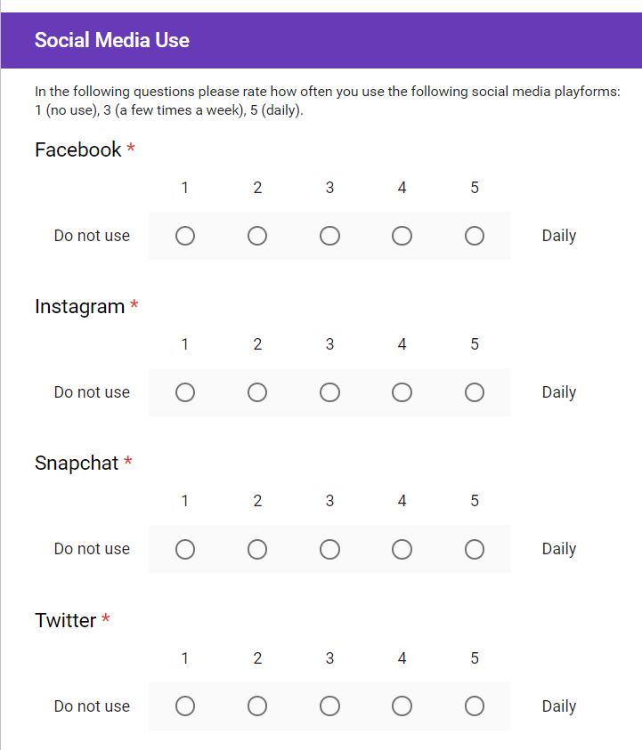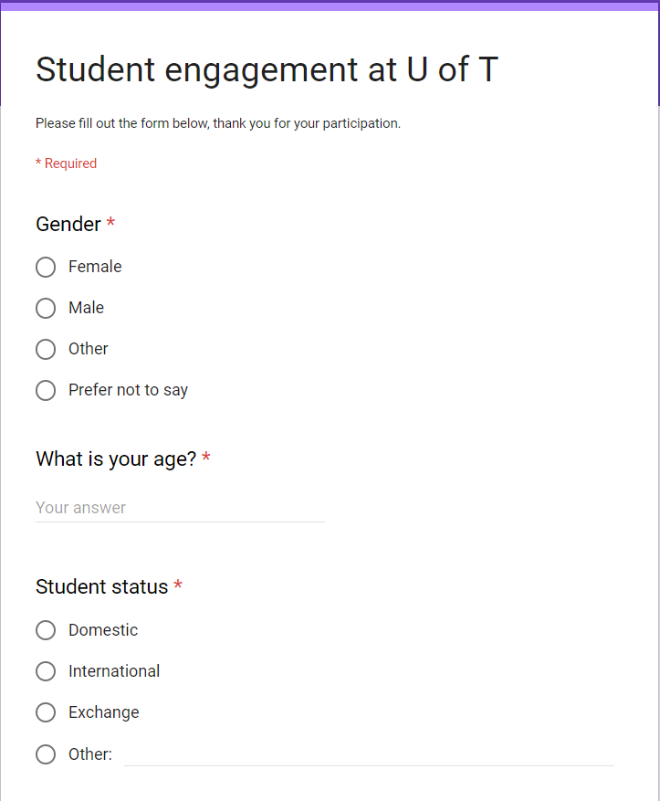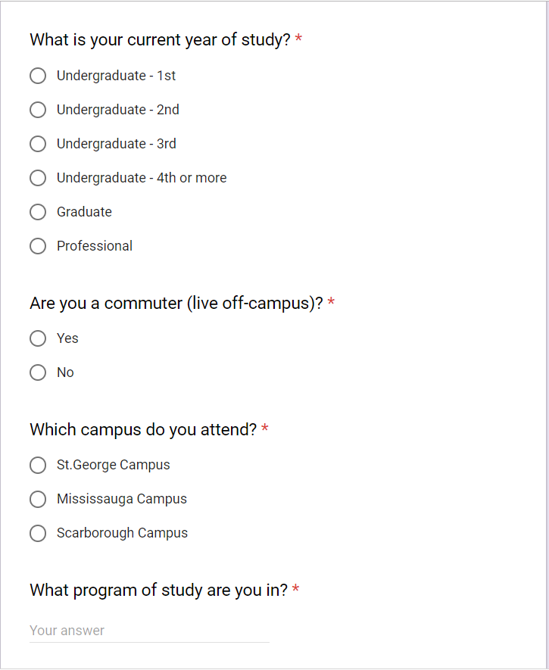

PAGE 2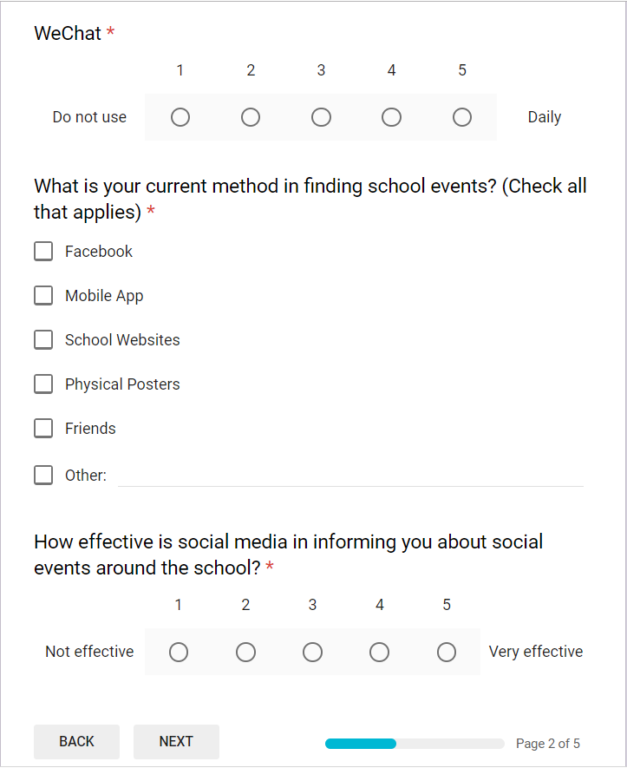

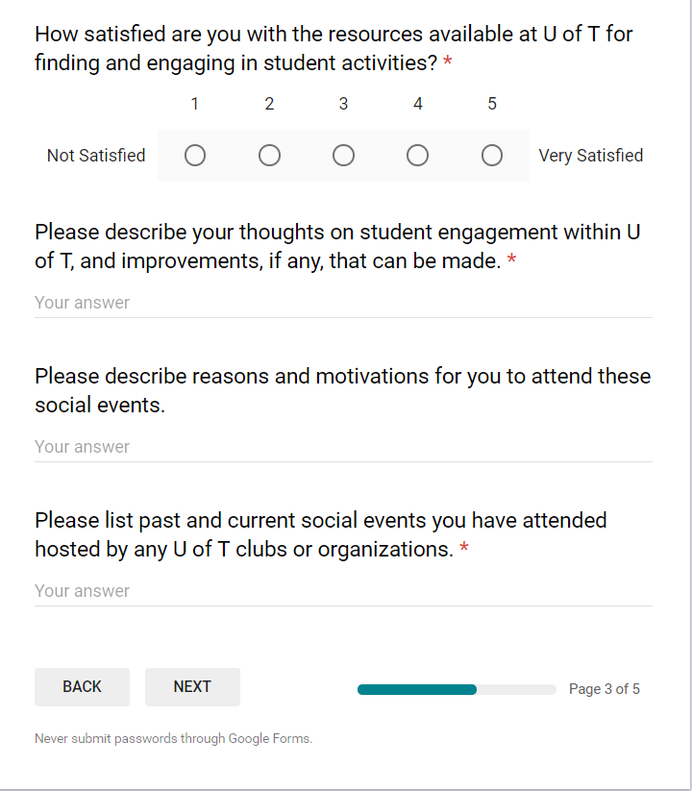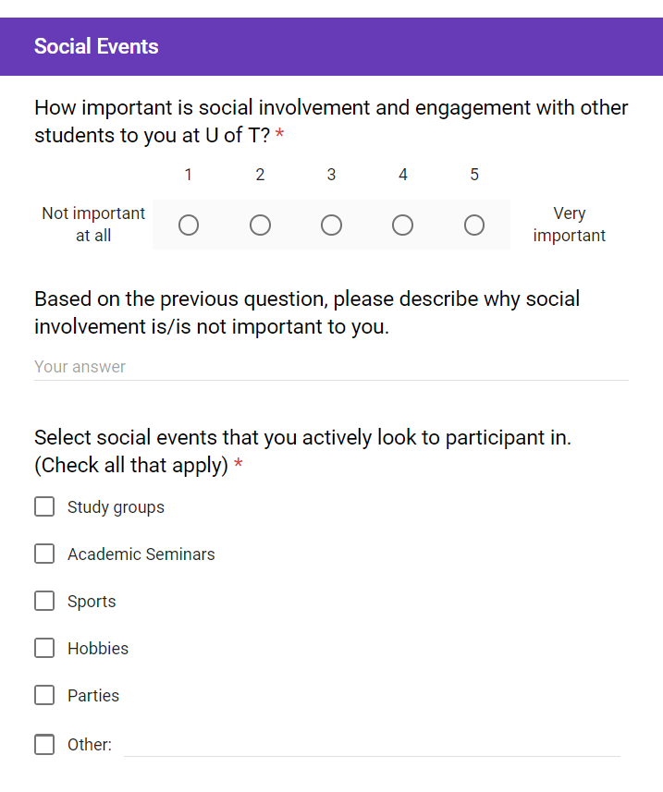

PAGE 3

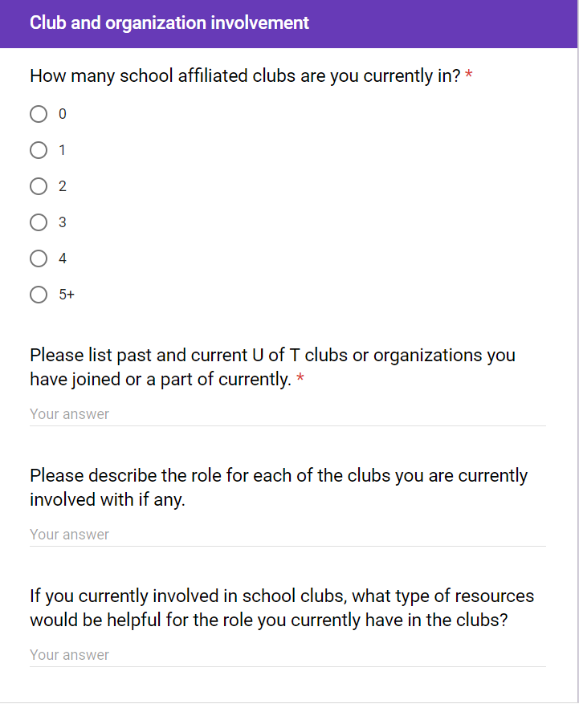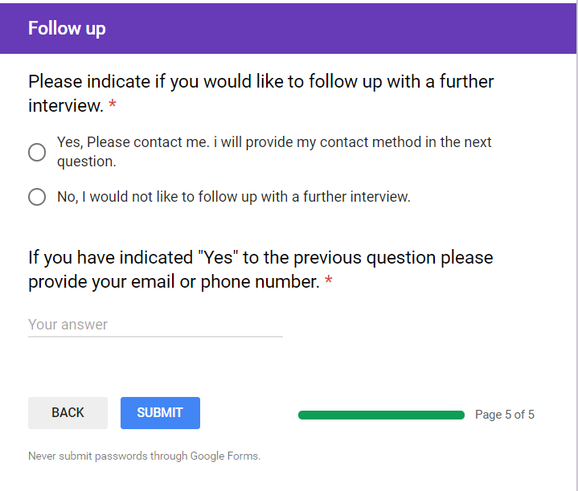

PAGE 5

PAGE 4

Interview Question Script

*WARM UP*

1. How’s your current time at U of T, what are you studying?
2. In terms of events at school, what kind of events interests you?
3. Do you find it hard to find these events?
4. How often do you go out to these event? Do you find yourself going more on weekends or is it better during the weekdays. How long roughly are these events?

*SCHOOL VS. SOCIAL LIFE*

1. Comparing school life and social life which do you think is more important?
2. Describe how you would balance your academic life and social life.
3. Describe the last time (if any) you ran into challenges where you faced problems with balancing academic life and social life? What do you think is part of the problem?
4. How would you cope with this type of challenge? Any strategies?

*SOCIAL EVENTS*

1. Focussing on social events, can you describe last time you tried to look for social events, what did you look for? What type of event was it?
2. How would you look to expand your social life at U of T? Any challenges?
3. Do you find students generally hang out within the same program?
4. In terms of expanding your social circle at U of T, can you describe any sort of challenges that you might face, or if you don’t? What makes it easier for you?
5. What would be your best strategy to talking to people?

*EXPERIENCE MAP QUESTION*

1. Can you go through the step-by step on how you would typically find an event.